|  |
| --- |
| Name: Senanayake Senanayake |
| Student Reference Number: 10899488 |

|  |  |  |
| --- | --- | --- |
| Module Code: PUSL 2078 | Module Name: Statistics for Data Science | |
| Coursework Title: PUSL 2078 Final Project Report | | |
| Deadline Date: 9 April 2024 | | Member of staff responsible for coursework: |
| Programme: BSc (Honours) Data Science | | |
| Please note that University Academic Regulations are available under Rules and Regulations on the University website [www.plymouth.ac.uk/studenthandbook](http://www.plymouth.ac.uk/studenthandbook). | | |
| **Group E**   |  |  | | --- | --- | | **ID No** | **Name** | | 10899483 | Fernando Naveen | | 10899488 | Senanayake Senanayake | | 10899178 | Konganige N Anthony | | 10899177 | Urulugastenne Amarakone | | 10899495 | Thehara Weerasiri |   ***We confirm that we have read and understood the Plymouth University regulations relating to Assessment Offences and that we are aware of the possible penalties for any breach of these regulations. We confirm that this is the independent work of the group.***  Signed on behalf of the group: FW Naveen | | |
| Individual assignment: ***I confirm that I have read and understood the Plymouth University regulations relating to Assessment Offences and that I am aware of the possible penalties for any breach of these regulations. I confirm that this is my own independent work.***  Signed : | | |
| Use of translation software: failure to declare that translation software or a similar writing aid has been used will be treated as an assessment offence.  I *have used/not used translation software.  If used, please state name of software………………………………………………………………… | | |
| **Overall mark _____% Assessors Initials ______ Date_________** | | |

**PUSL 2078**

**Statistics for Data Science**

**Final Project Report**

**Workload Matrix.**

|  |  |  |
| --- | --- | --- |
| **Plymouth ID** | **Name** | **Contribution** |
| 10899483 | Fernando Naveen | Data modeling – Linear regression analysis |
| 10899488 | Senanayake Senanayake | Comparison and Identifications of economic highlights |
| 10899178 | Konganige N Anthony | Generating the economical recommendations based on the comparison and the identification of Sri lankas economical highlights |
| 10899177 | Urulugastenne Amarakone | Data modeling – Time series analysis |
| 10899495 | Thehara Weerasiri | Country comparison using data visualization |

**Contents**

Introduction 4

Country comparison using GDP. 5

Background 5

Reasons for GDP being a crucial metric for comparison 5

GDP of the top 30 countries in Asia for the year 2022 6

Countries aligning with Sri Lanka’s GDP for the year 2022 7

Comparisons and Identification of Economic Highlights 8

Background 8

Sri Lanka 9

Oman vs Sri Lanka 10

Qatar vs Sri Lanka 10

Kuwait vs Sri Lanka 11

Data Modeling 12

Regression Analysis 14

Time series analysis 25

Recommendations For Sri Lanka 30

Conclusion 33

References 34

# Introduction

Comprehending global socio-economic trends is critical for making educated decisions in an era of growing globalization and interconnection. This research explores a thorough examination of socioeconomic data from many countries across the world, derived from the World Bank dataset. This project's main goal was to identify recurring patterns and draw practical conclusions for Sri Lanka's economic situation.

It is more important than ever to navigate economic crises with skill as the world faces previously unheard-of difficulties. As a result, this paper looks at how different countries handled comparable situations and tries to identify lessons and best practices that could be applied to Sri Lanka.

A strategy with multiple facets was used to accomplish these aims. Many methods of data visualization were applied to show complex relationships and patterns in the dataset. To find hidden patterns and project possible paths, advanced data modeling techniques were also used.

Moreover, the analysis goes beyond simple modelling and visualization; it also includes a qualitative analysis of the choices and approaches used by nations dealing with comparable economic difficulties. Through the integration of empirical data and these findings, the paper endeavors to develop well-informed suggestions specific to Sri Lanka's particular situation.

The report essentially acts as a guide, assisting stakeholders and policymakers in Sri Lanka as they navigate the complex web of international socioeconomic processes. Through the utilization of data-driven insights and global expertise, it aims to facilitate Sri Lanka's transition towards a more resilient and prosperous future.

# Country comparison using GDP.

## Background

Evaluating each nation’s economic production per person is necessary when comparing them using GDP per capita. The total worth of products and services generated inside a nation’s boundaries over a certain time period measured by the GDP, gross domestic product. GDP per capita, when divided by the population, yields an estimate of the average income for that nation’s citizens.

## Reasons for GDP being a crucial metric for comparison

1. **Standard of living** – The average level of living in a nation can be determined by looking at its GDP per capita. A higher GDP per capita is usually associated to infrastructure, healthcare, and education, among other goods and services.
2. **Economic development** – Higher GPD per capita nations usually have more developed economies with superior services, technology, and industries. Lower-income countries might give higher GDP per capita priority in order to raise living standards and boost economic expansion.
3. **Investment potential** – When evaluating a nation’s investment potential, investors frequently take its GDP per capita into account. A more stable and wealthy economy may be indicated by a higher GDP per capita, which would encourage international investment and corporate expansion.

To compare the Gross Domestic Product (GDP) of several countries bar plots were used as the visualization method for the ease of comparisons.

## GDP of the top 30 countries in Asia for the year 2022

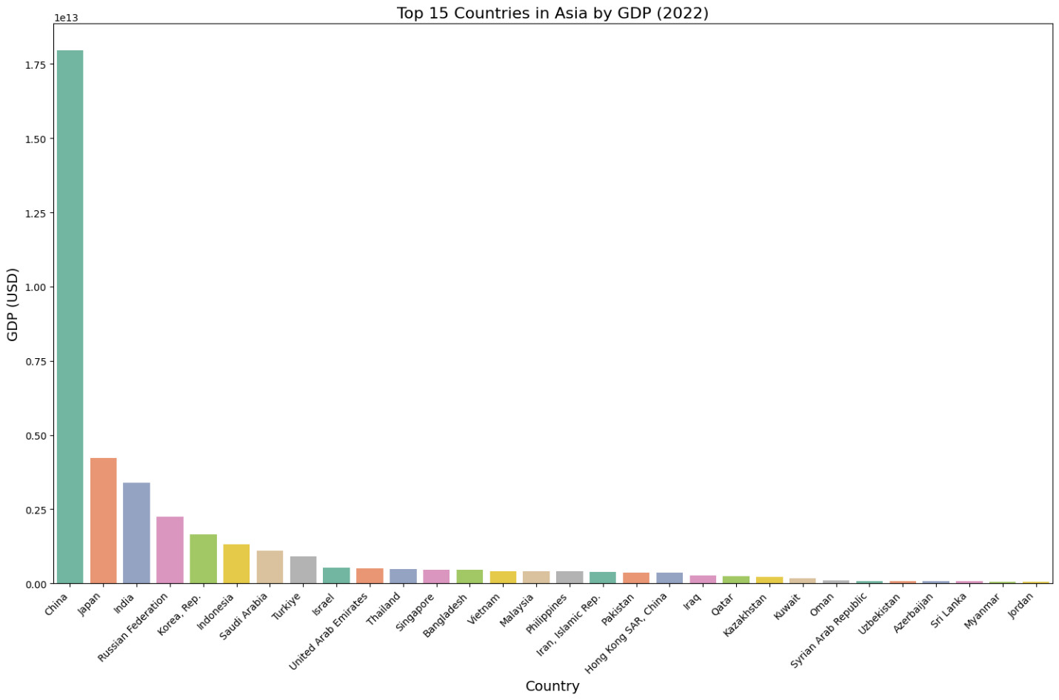

**About the bar plot:**

The results of this bar plot, with each nation represented by a bar and color-coded in accordance with the given palette, displays the GDP of the top 30Asian countries for the year 2022. The names of the countries appear on the x- axis, while GDP figures in USD appear on the y-axis.

**Analysis of the bar plot:**

By analyzing the above bar plot, we can see that China is the country with the highest GDP followed by Japan and India. According to this bar plot, Sri Lanka is ranked in the 28th position.

Apart from the top 5-10 countries the rest of the countries have a clear difference in GDP levels. So, for comparisons it is not effective to compare Sri Lanka with the top 10 countries as we can see a clear difference between the GDPs of Sri Lanka and the top 10 countries.   
Due to this reason let’s get the countries which has GDPs that is aligning with Sri Lanka.

## Countries aligning with Sri Lanka’s GDP for the year 2022

**About the bar plot:**

The GDP of nations comparable to Sri Lanaka is shown in this bar plot for the year 2022, with each country represented by a bar and color-coded using the designated palette. Country names are displayed on the x- axis and GDP numbers in USD are displayed on the Y-axis.

**Analysis of the bar plot:**

By analyzing the above plot, we can see the countries who are closely aligning and above Sri Lanka according to rankings. With this bar plot we have chosen the countries for the comparison of GDPs and economic highlights and trend patterns which will be useful for the comparisons and finding suitable recommendations for upliftment of Sri Lanka’s GDP to higher level.

# Comparisons and Identification of Economic Highlights

## Background

For the comparison of Sri Lanka’s GDP, the fellow countries which were closely ranked with Sri Lanka were selected by the bar plot which is described above. After selecting the countries, line charts were plotted for each of those countries with respective to Sri Lanka. The line charts which were plotted can be seen below.

The line charts were plotted for the countries Azerbaijan, Uzbekistan, Syria, Oman, Kuwait, Kazakhstan, and finally Sri Lanka. When we analyze the above line plots, we can see that most of the GDP lines are relatively similar to Sri Lanka. To make better comparisons of Sri Lanka’s GDP with the other countries in the bar plots, countries like Oman, Qatar and Kuwait were selected. The reason for this is by analyzing all the line plots we can see these specific countries have achieved a remarkable success after 2020 in terms of GDP according to the line plots. So it will be effective to compare those countries with Sri Lanka and explore their strategies and plans which resulted their GDP’s to grow after 2020 period.

Sri Lanka**:**

The country's main economic sectors include tourism, tea export, apparel, textile, rice production, and agricultural products, with overseas employment playing a significant role in foreign exchange. In 2002, Sri Lanka's economy began to recover, allowing the country to reduce defence spending and focus on controlling its significant public sector debt. The service sector experienced robust growth, contributing to a 4% economic growth, while the agricultural sector experienced a small recovery. During the Sri Lankan Civil War (1983–2009), hopes for investment and economic growth were raised by the ceasefire and peace negotiations. During the brief peace process from 2002 to 2004, the economy profited from lower interest rates, a resurgence of the stock exchange, increased FDI, domestic demand recovery, and tourist arrivals. The catastrophic tsunami, which caused extensive damage and many fatalities, especially in coastal areas, had a major effect on Sri Lanka's economy in 2004. The 2005 civil war resulted in a significant rise in defence spending and increased violence, prompting some donor nations to reduce their aid to the nation. The war's decades-long duration gave previously war-affected areas a chance to focus on economic growth and reconstruction in 2009. After the civil war ended in 2009, the economy experienced growth of 8.0% in 2010 and 9.1% in 2012, but the boom ended in 2013, with GDP recovery slightly in 2014. Sri Lanka's economic downturn in the mid to late 2010s was threatened by rising debt levels and a political crisis, leading to a downgrade in its debt rating. The EU's 2016 ban on Sri Lankan fish products was reversed, leading to a 200% increase in fish exports to the EU. Bloomberg listed Sri Lanka as one of the nations offering the greatest risk to investors. Furthermore, growth slowed down to 2.3% in 2019 compared to  3.3% in 2018. Between 2015 and 2019, the rupee's value decreased from 131 to 182, leading to increased foreign debt and decreased domestic consumption, marking the end of relative stability. The terrorist strikes on Sri Lankan hotels and churches had a negative impact on tourism, a vital economic sector, which resulted in lower GDP growth forecasts in 2019. According to the World Bank's Sri Lanka Development Update, the pandemic had a substantial negative impact on Sri Lanka's tourism sector, which is a significant source of foreign exchange. It also disrupted global supply chains, which caused the country's GDP to contract in 2023. In the early 2020s, the heavily indebted nation is going through an economic crisis that has left residents suffering from months-long shortages of fuel, food, and electricity.

In April 2022, the nation defaulted on its sovereign debt due to high foreign debt, economic mismanagement, and decreased tourism revenue, resulting in a 7.8% economic decline. Inflation has reached a peak of 57%, as per official data Because of these problems GDP of Sri Lanka faced an instant downfall. There were no proper recovery plans to uplift the country’s GDP. As a result , prime minister Ranil Wickremesinghe announced in parliament in June 2022 that Sri Lanka's economy had collapsed and that the country was no longer able to afford necessities.

Oman vs Sri Lanka**:**

When we compare Oman’s GDP with Sri Lanka, we can see both the lines are relatively similar to each other. Here the highlighting point is that both country’s GDP has been in a downfall till 2020 and then Oman’s GDP has gained a remarkable uptrend while Sri Lanka’s GDP has fallen further. The reason for Sri Lanka’s downfall was discussed earlier. When we focus on Oman’s remarkable uptrend, we can find the reasons for that by doing some research. According to IMF reports and Oman’s Central Bank reports we can see some major reasons. Among them “The Kazzan Project” can be sighted as a remarkable recovery plan. Through this they have increased their gas production apart from oil while oil is a key factor in Oman’s economy. Also the Special Economic Zone Authority of Duqm (SEZAD) secured $14.2 billion in investments through usufruct agreements until 2018. The largest in the Middle East and North Africa, Duqm comprises sea port, industrial area, new town, fishing harbor, tourist zone, logistics center, and education and training zone all of which are supported by a multimodal transport system that connects it with nearby regions. So with these moves they have started to focus more on other different areas apart from their key economic factors so that they could increase their GDP.As we saw in the plot, Oman has gained better results through these plans.

Qatar vs Sri Lanka**:**

We can see the GDP lines of Qatar and Sri Lanka has a difference when it comes to numbers but when we analyze the trend patterns, we can see that Qatar’s GDP has also gone down in the same time period as Sri Lanka. Again the remarkable fact is that after 2020 Qatar’s GDP as also risen to a greater extent and we can see a sudden uptrend in the line plot. According to sources, there are number of reasons for this. Qatar is also a country who depends mostly on oil and gas. So, when they faced the economic downfall they explored some other effective options. Among them they have considered hosting the FIFA World Cup in Qatar. FIFA World Cup is a major sporting event in the world which draws attention of the entire world. So they hosted FIFA World Cup 2022. Due to numerous reasons this has made a major impact for Qatar’s economy. Qatar is not among the major countries playing football, but this move has helped them a lot to boost their economy. In the line plot we can see how good the results were because of these kinds of plans.

Kuwait vs Sri Lanka**:**

When comparing the GDPs of Sri Lanka and Kuwait when we focus on the period prior to 2020 and the period after 2020, we can see that there is a downfall of Kuwait’s GDP in the period prior to 2020. But after 2020 Kuwait has taken their GDP growth to a positive state. According to World Bank reports, Kuwait’s economy was in a downfall because of the oil price reduction. Kuwait is also a country which depends mostly in oil production. So, the reduction of oil prices badly affected their GDP. After 2020 with the Covid-19 pandemic it was not easy to take their GDP growth to an increasing level. As recovery plans Kuwait government started spending more on uplifting crucial areas like infrastructure, healthcare, and education. On the other hand, Kuwait banks increasing lending of credits to individuals and businesses so that it will be easier for investments and expansion of local businesses. Kuwait has launched “Shagaya Renewable Energy Park”, its largest renewable energy facility, as part of its Vision 2035 initiative, which includes wind, solar photovoltaic, and concentrated solar power plants. With the help of these measures, they were able to see results mainly from 2022 onwards and because of that we can see an uptrend in Kuwait’s economy after 2020 period while Sri Lanka’s GDP has an instant downtrend after 2020.

# Data Modeling

Numerous socioeconomic factors have a significant impact on Sri Lanka's economic health. Comprehending the correlations between these variables and GDP is essential for well-informed economic strategizing and policy formulation. The purpose of this section is to use time series analysis and linear regression to create a data-driven model that can be used to estimate Sri Lanka's GDP.

1. **Linear Regression:**

To determine the correlations between GDP and other pertinent socio-economic factors, we shall construct a linear regression model. We can learn a great deal about how these variables affect the nation's economic growth by examining the model's coefficients.

1. **Time Series Analysis:**

To examine trends, seasonality, and possible autocorrelations in Sri Lanka's GDP data, we shall make use of time series approaches. We will be able to see trends and possible predicting opportunities thanks to this analysis.

**The following actions will be covered in this section on data modelling.**

* **Data Exploration:** We will examine the socioeconomic data that is currently available for Sri Lanka with an emphasis on possible GDP predictors. Preprocessing and cleaning of the data will be done to make sure it is suitable for analysis.
* **Time Series Analysis:** To comprehend Sri Lanka's GDP statistics over time, we will use methods such as trend analysis, seasonality decomposition, and autocorrelation tests.
* **Linear Regression Model Building:** The impact of socioeconomic determinants on GDP will be estimated through the training and evaluation of a linear regression model. Techniques for feature selection could be used to maximize the performance of the model.
* **Model Evaluation:** To determine how well the linear regression model predicts GDP, we will evaluate its performance using a variety of metrics ( R-squared and Mean Absolute Error).

The creation of a trustworthy model that clarifies the variables impacting Sri Lanka's economic growth is the ultimate objective of this section on data modelling. The model may also prove to be a useful instrument for projecting future GDP patterns and guiding policy choices.

## Regression Analysis

We began our regression analysis by looking at the correlations between the variables to determine which socioeconomic factors had the biggest impact on a nation's GDP. Our main goal was to identify the socioeconomic variables that have the biggest influence on a country's GDP (gross domestic product). To achieve this, we carefully collected relevant data from the extensive dataset that the World Bank made available.

Through close examination of the correlations, we were able to identify which variables had the strongest correlations with a nation's economic production by taking this first step. With this knowledge in hand, we were then able to carefully choose the independent variables, or socio-economic components, that showed the greatest promise for use as GDP predictors.

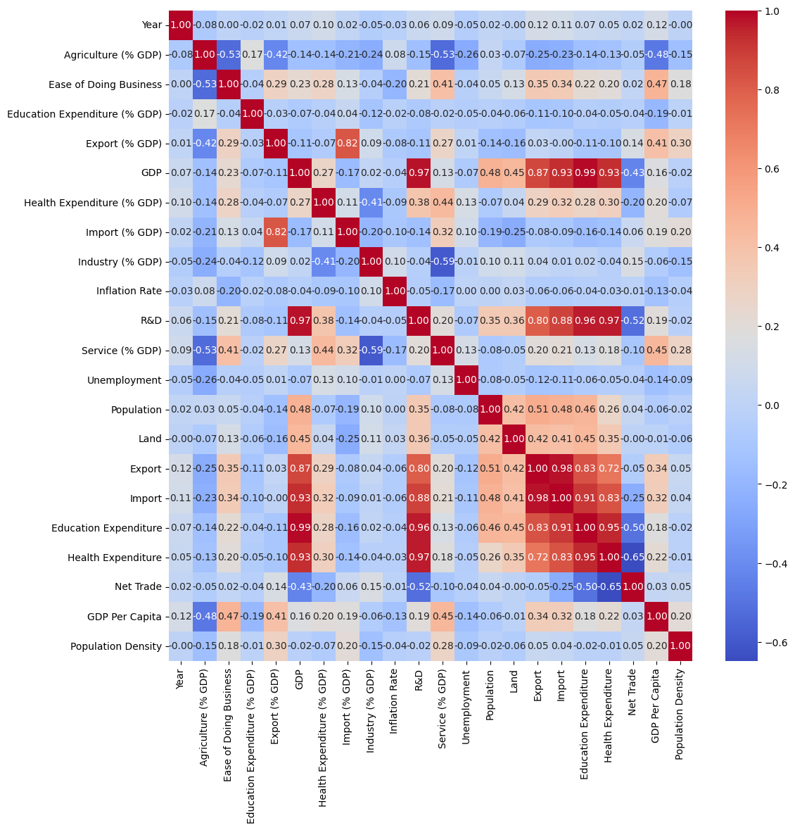

The correlation heatmap study revealed that there was a significant positive association between Sri Lanka's GDP and health and education expenditure. Therefore, health expenditure was selected as the independent variable for our regression analysis among these significant factors. Finding out the nature of the relationship between Sri Lanka's GDP and health expenditure is the aim of this analysis.

Our goal is to clarify the degree to which investments in healthcare services, infrastructure, and related costs affect the nation's economic output by concentrating on health expenditure as the independent variable. We aim to provide important insights into the socio-economic dynamics of Sri Lanka by statistically evaluating the strength and direction of this link through rigorous regression analysis.

**Linear Regression Analysis**

Linear regression was selected as the analysis method to investigate the relationship between health expenditure and GDP in Sri Lanka because of its interpretability and application. Given the nature of the link we are trying to explore, the assumption of linearity between the independent variable (health expenditure) and the dependent variable (GDP) is acceptable. By leaving other variables constant, we may calculate the projected change in GDP for a unit increase in health expenditure by using the coefficients determined using linear regression, which have simple meanings. Because of their simplicity, different stakeholders may simply access and communicate the results. Furthermore, linear regression functions as a basic model, providing a point of departure for more complex studies when necessary.

**Implementation**

We have chosen Python programming language to do the implementation.

1. **Importing the required libraries.**

1. **Loading the dataset and splitting the data into training and testing datasets.**



1. **Checking for any missing values or NA values in training and testing dataset**

There are no missing values in the training and testing dataset.

1. **Check for useful descriptive statistical values.**

1. **Defining the dependent and the independent variables for training and testing data.**

1. **Exploring the relationship between the dependent and independent**

**variables.**



The graphical representations above make evident how strongly the GDP and health expenditure is related.

Linear regression usually looks like this,

Here, we are attempting to produce "a" by adding a constant to our dataset, since we already have "y" and "x." It matters in terms of computation. We'll be using the statsmodel library's "add_constant()" function.

1. **Defining the model and fitting it.**

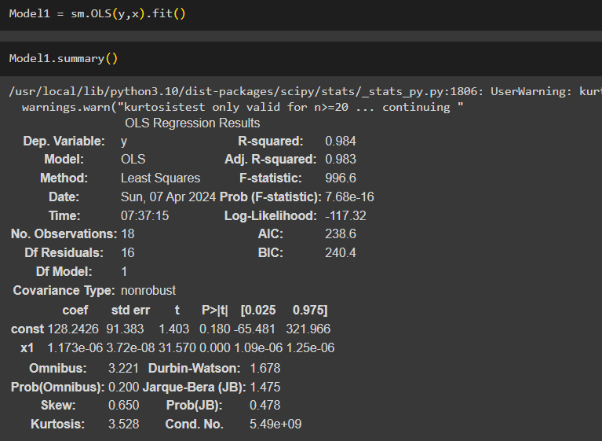

We obtained "const" and "x1" from the "Model1" summary, which are useful in constructing our final regression equation.

y – GDP of Sri Lanka

x – Health Expenditure

128.242 is the coefficient of health expenditure (x). This illustrates the line's slope. It shows that y rises by 128.242 units for every unit increase in health expenditure. Accordingly, GDP (y) increases at a rate of 128.242 units per unit change as health expenditure (x) increases.

From the above model summary, we can get a better understanding about the relationship between the GDP and the health expenditure of Sri Lanka.

**R – squared :-**

The percentage of the variance in the dependent variable that can be predicted from the independent variable is known as the coefficient of determination.   
  
When the dependent variable cannot be predicted from the independent variable, the R2 value is 0.  
  
When the dependent variable and the independent variable can be predicted accurately, the R2 value is 1.

With an R2 of 0.984, 98.4% of the variance in GDP (y) can be predicted from Health Expenditure (x).

1. **Visualizing the regression line fitment on the data.**

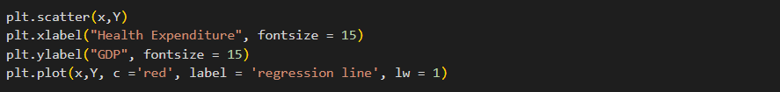

1. **Using matrices to evaluate the performance of the regression model.**
2. **Mean Absolute Error (MAE):** It calculates the mean absolute difference between the actual and projected values. The equation shown below is used to calculate the

MAE. The best value for this is 0. By considering both overestimations and underestimations and not unduly penalizing huge errors, MAE offers a clear indicator of the model's accuracy.

1. **Mean Squared Error (MSE):** The difference between the expected and actual numbers is calculated as the average of the squares. Because of the squaring procedure, MSE penalizes greater errors more severely than smaller errors. Because significant errors contribute disproportionately to the overall value, it is especially vulnerable to outliers. The best value for this is 0.

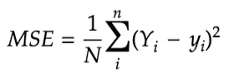

1. **Root Mean Squared Error (RMSE):** the square root of the squared error means. The best value for this is 0.

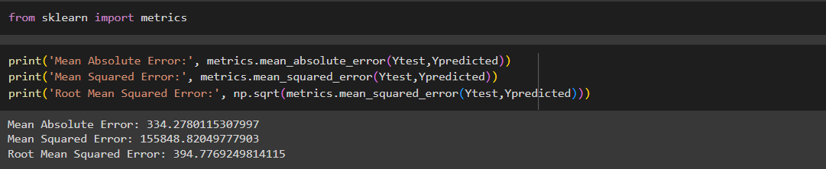

From our linear model we got the following.

1. **Mean Absolute Error (MAE):** 334.27801

The model's average prediction error (MAE) is 334.27801, meaning that it is off by about 334.28.

1. **Mean Squared Error (MSE):** 155848.82049

The average squared difference between the expected and actual values is roughly 155848.82, as indicated by the MSE of 155848.82049.

1. **Root Mean Squared Error (RMSE):** 394.77692

An RMSE of 394.77692 indicates that the model's predictions are inaccurate by about 394.78 on average.

Although high MSE, MAE, or RMSE values may cause concern, their importance varies depending on several variables, including the context of the problem, how the model is compared to other models, and how it affects decision-making processes. But because the data on the GDP and Health expenditure are very large, having a higher MSE,MAE and RMSE is acceptable.

## Time series analysis

**GDP predictions**

A Gross Domestic Product (GDP)of a country is a giant financial scoreboard. It calculates the total value of all commodities and services produced inside the country boundaries for a given time period , usually a quarter or a year. In essence, it displays the amount of goods that a country produces and exports. Therefore, a high GDP typically indicates a strong economy, whereas a low GDP implies potential economic difficulties and problems. As a summery GDP is a measurement that we can identify a financial status of a country .

The ARIMA model can capture both long-term trends and short-term volatility, they are a good fit for estimating Sri Lanka's GDP. The moving average, autoregressive, and differencing components of ARIMA allow it to properly account for trends, seasonality, and random fluctuations in GDP data. Through diagnostic tests, the statistical framework of ARIMA enables the evaluation of model fit, guaranteeing accuracy and dependability. Nevertheless, ARIMA does not account for all the complicated elements that affect GDP. Performing extra analysis and considering other variables can improve the prediction power and yield a more thorough picture of the GDP dynamics in Sri Lanka.

And ARIMA (Autoregressive Integrated Moving Average) is a model that used to predict time-series data, such as stock prices or sales figures. It consists of three primaries.

In this plot we can correctly identify the blue line that used to display the actual GDP value till 2022. The substantial decline in Sri Lanka's GDP in 2019 is captured by the ARIMA model. This is consistent with our understanding of the effects of the attacks on Easter Sunday Bombing Attacks . The Central Bank of Sri Lanka reports that revenue from tourism directly contributes 4-5% to the country's GDP. After the bombings the number of visitors dropped 70% in following to the attacks. The substantial reduction in the 2019 GDP shown in the plot is probably explained by this decline in tourism revenue. Furthermore, the COVID-19 pandemic's extra damage to Sri Lanka's economy is reflected in the model's ongoing downward trend in 2020.

**Predictions**

The big red dot shows the GDP projected by the ARIMA model for 2023, which is greater than year 2022. Considering Sri Lanka's efforts to recover economically.

1. **Post-Pandemic Recovery:**

Based on a 6.4% growth prediction, the World Bank expects Sri Lanka's economy to revive in 2023 . This gain is linked to both an increase in tourism and a revival of domestic economic activity.

1. **Tourism Rebound**:

Since the epidemic lows, Sri Lanka has seen a steady increase in the number of visitors. Over 600,000 tourists visited Sri Lanka in 2022, and more are anticipated in 2023 . The GDP of Sri Lanka is significantly boosted by this increase in tourism.

1. **Global Economic Uncertainty:**

Sri Lanka's export revenue and foreign investment may be negatively impacted by the global economic downturn and growing inflation also impact badly on exporters that will be a huge bad effect for Sri Lanka ‘s GDP growth.

1. **High Debt Levels:**

Because of Sri Lanka‘s substantial external debt, Sri Lanka may not be able to make as many investments in industries that encourage growth.

The GDP prediction for 2023 is represented by the confidence interval around the red dot, which is colored in yellow. The model is less confident in its prediction the wider the band. Therefore, even if the red dot indicates a greater GDP, the real result may be lower based on the previously described criteria.   
  
Looking forward , the ARIMA model-based projected GDP trajectory is shown by the yellow dots that stretch until 2032. It's crucial to keep in mind that these are only projections and that uncertain events could cause the real GDP to diverge from this course.

1. **Government Policies:**

Future GDP growth in Sri Lanka will be greatly impacted by the government's policies regarding infrastructure development, Digital infrastructure development, trade liberalization, and luring foreign investment.

1. **Global Economic Conditions**:

The movements in the global economy might affect Sri Lanka's economy. Strong international economic conditions would boost Sri Lanka's export and tourism industries and raise the count of Sri Lankan GDP.

**Model Evaluation.**

Model evaluation uses metrics such as MAE, MSE, and RMSE to evaluate ARIMA's prediction ability. Predictions are impacted by uncertain events such as political instability and COVID-19 because they introduce unpredictable dynamics, compromise data quality, and violate model assumptions. Robust modeling tools and an understanding of the constraints in the accuracy of forecasting in uncertain contexts are necessary to meet these issues.

# Recommendations For Sri Lanka

These recommendations are based on above decisions which other countries made to improve their countries’ economic growth.

1. Develop incentive schemes and make bank loans more accessible in order to bolster the expansion of important non-oil sectors like manufacturing, services, tourism, gem and agriculture. ( since Sri Lanka doesn’t have oil as a natural resource)
2. Pay special attention to locating and fostering industries with significant room for expansion, such as those in technology, renewable energy, and export-oriented sectors.
3. Simplify loan approval procedures and guarantee small and medium-sized businesses' (SMEs') equitable access to capital in order to promote innovation and entrepreneurship.
4. Prioritize sustainable development strategies and offer targeted assistance and incentives to sectors of the economy with the potential to boost GDP and generate jobs.
5. Implement multi-year socioeconomic development programs that are suited to Sri Lanka's unique opportunities and challenges, with an emphasis on food security, sustainable development, poverty reduction, and economic diversification.
6. Create and carry out a transparent privatization plan for State Owned Enterprises (SOEs), including domestic initial public offerings (IPOs), in order to prioritize fair competition and protect worker interests while enhancing efficiency, competitiveness, and innovation across key sectors.
7. Adopt tax reforms to improve efficiency, competitiveness, and productivity in the economy by professionalizing the private sector, streamlining the tax code, and promoting business consolidation.
8. To increase employment opportunities and the overall number of employed people, concentrate on promoting sustained economic growth. This will enhance social well-being and overall economic prosperity.
9. To increase the agricultural sector's GDP and employment, it should be strengthened and diversified. Value-added products, technology adoption, and modernization should be prioritized in order to maximize productivity and resilience to shocks from the outside world.
10. Utilize the fishing and trading industries' coastal resources and advantageous geographic location to grow and diversify them. In addition, encourage sustainable practices and look into opportunities for value addition.
11. Implement policy initiatives like commercial arbitration centers, revising laws for commercial companies, and simplifying licensing processes to boost investment, encourage entrepreneurship, and boost economic growth.
12. Develop a strategic plan for economic diversification, focusing on key industries like manufacturing, energy, mining, tourism, agriculture, fisheries, and logistics, to promote sustainable growth in line with Sri Lanka's unique assets.
13. Special economic zones (SEZs) are development hubs with extensive infrastructure, strategically located to support long-term economic growth and development, attracting investments, promoting industrialization, and generating job opportunities.
14. Large-scale renewable energy projects like wind, solar photovoltaic, and concentrated solar power plants are recommended to reduce fossil fuel reliance, enhance energy security, promote sustainability, and create new business opportunities.
15. Establishing or upgrading a sovereign wealth fund is crucial for managing foreign investments, promoting revenue diversification, and ensuring responsible financial resource management for long-term economic stability and prosperity.
16. Develop and implement a national investment strategy aiming to enhance the investment climate, attract foreign capital, and promote economic growth through incentives, infrastructure development, and reforms.
17. Develop a comprehensive tourism development plan, aiming to boost hotel capacity and visitor numbers, with government investment in infrastructure and private sector involvement for sustainable growth.
18. Expand tourism offerings to cater to diverse market segments, such as hosting international sporting events, developing cultural tourism through landmarks, or utilizing major events to boost business and economic impact.

# Conclusion

In conclusion, this report provides insight into important socio-economic patterns that were discovered by a thorough examination of data worldwide, made possible by the World Bank dataset. By utilizing data visualization and modeling approaches, we have uncovered subtle insights that provide light on the global economic environment, including that of Sri Lanka.

Through the analysis of other countries' responses to comparable economic crises, we have discovered priceless insights and optimal methodologies that might guide strategic decision-making in Sri Lanka. The experiences of other nations provide a rich tapestry of techniques that can be customized to fit Sri Lanka's particular circumstances, ranging from creative stimulus measures to cautious fiscal policies.

Nonetheless, it is critical to recognize the inherent uncertainties and complexities that come with economic forecasting and policymaking. Data-driven insights are a good starting point, but they also need to be flexible and agile enough to change with the times.

In the end, this report's recommendations act as a compass, pointing Sri Lanka in the direction of a more resilient and prosperous future. Sri Lanka can confidently and resolutely manage the tumultuous waters of economic instability by utilizing the richness of global expertise at our disposal and moving forward with strategic forethought.

# References

*Accumulation for Future Generations: Kuwait’s Economic Challenges*. (n.d.). Retrieved from IMF: https://www.elibrary.imf.org/display/book/9781557756237/ch02.xml

*Annual Report 2022*. (n.d.). Retrieved from QCB: https://www.qcb.gov.qa/PublicationFiles/QCB%20Annual%20Report-EN-15.pdf

*CBSL Annual Report - Fiscal Policy and Government Finance*. (n.d.). Retrieved from CBSL: https://www.cbsl.gov.lk/sites/default/files/cbslweb_documents/publications/annual_report/2019/en/10_Chapter_06.pdf

*Central Bank of Oman Annual Report*. (n.d.). Retrieved from CBO: https://cbo.gov.om/sites/assets/Documents/English/Publications/AnnualReports/AnnualReport2014.pdf

*Kuwait’s economy gains temporary breathing space*. (n.d.). Retrieved from The Banker: https://www.thebanker.com/Kuwait-s-economy-gains-temporary-breathing-space-1680249408#:~:text=After%20a%20lacklustre%20performance%20since,in%20both%20prices%20and%20production.

*Kuwait's Economy Update*. (n.d.). Retrieved from World Bank: https://www.worldbank.org/en/country/gcc/publication/economic-update-october-2020-kuwait

*Sri Lanka : Selected Issues*. (n.d.). Retrieved from IMF: https://www.imf.org/en/Publications/CR/Issues/2022/11/10/Sri-Lanka-Selected-Issues-Sri-Lanka-Selected-Issues-525593

*World Bank Country and Lending Groups*. (n.d.). Retrieved from World Bank: https://datahelpdesk.worldbank.org/knowledgebase/articles/906519-world-bank-country-and-lending-groups